**IFT598: Middleware Programming & Database Security**

Arizona State University

Assignment 7: Data Access

**Student**

Chih-Chieh Chang

**Professor**

Dinesh Sthapit

October 2, 2022

* Screenshots contain table view

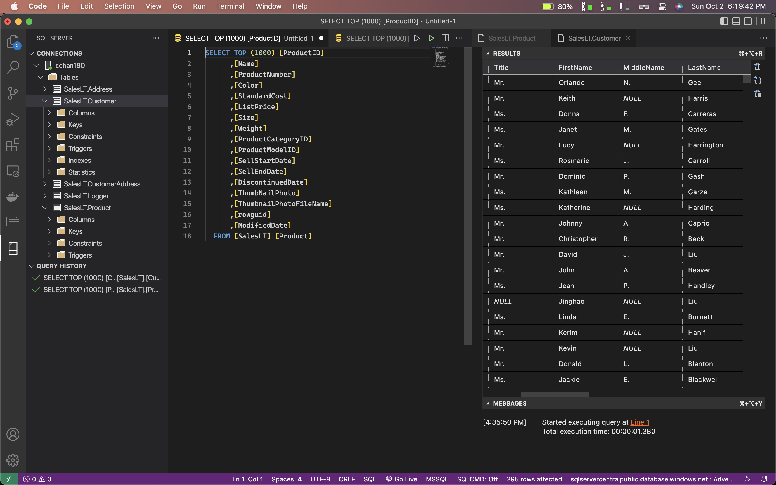

* Created Correct Individual SQL SELECT Statement to Query Data in four Tables

Provide the SQL Statements that you used to get Customers from the Database.

* + Customers

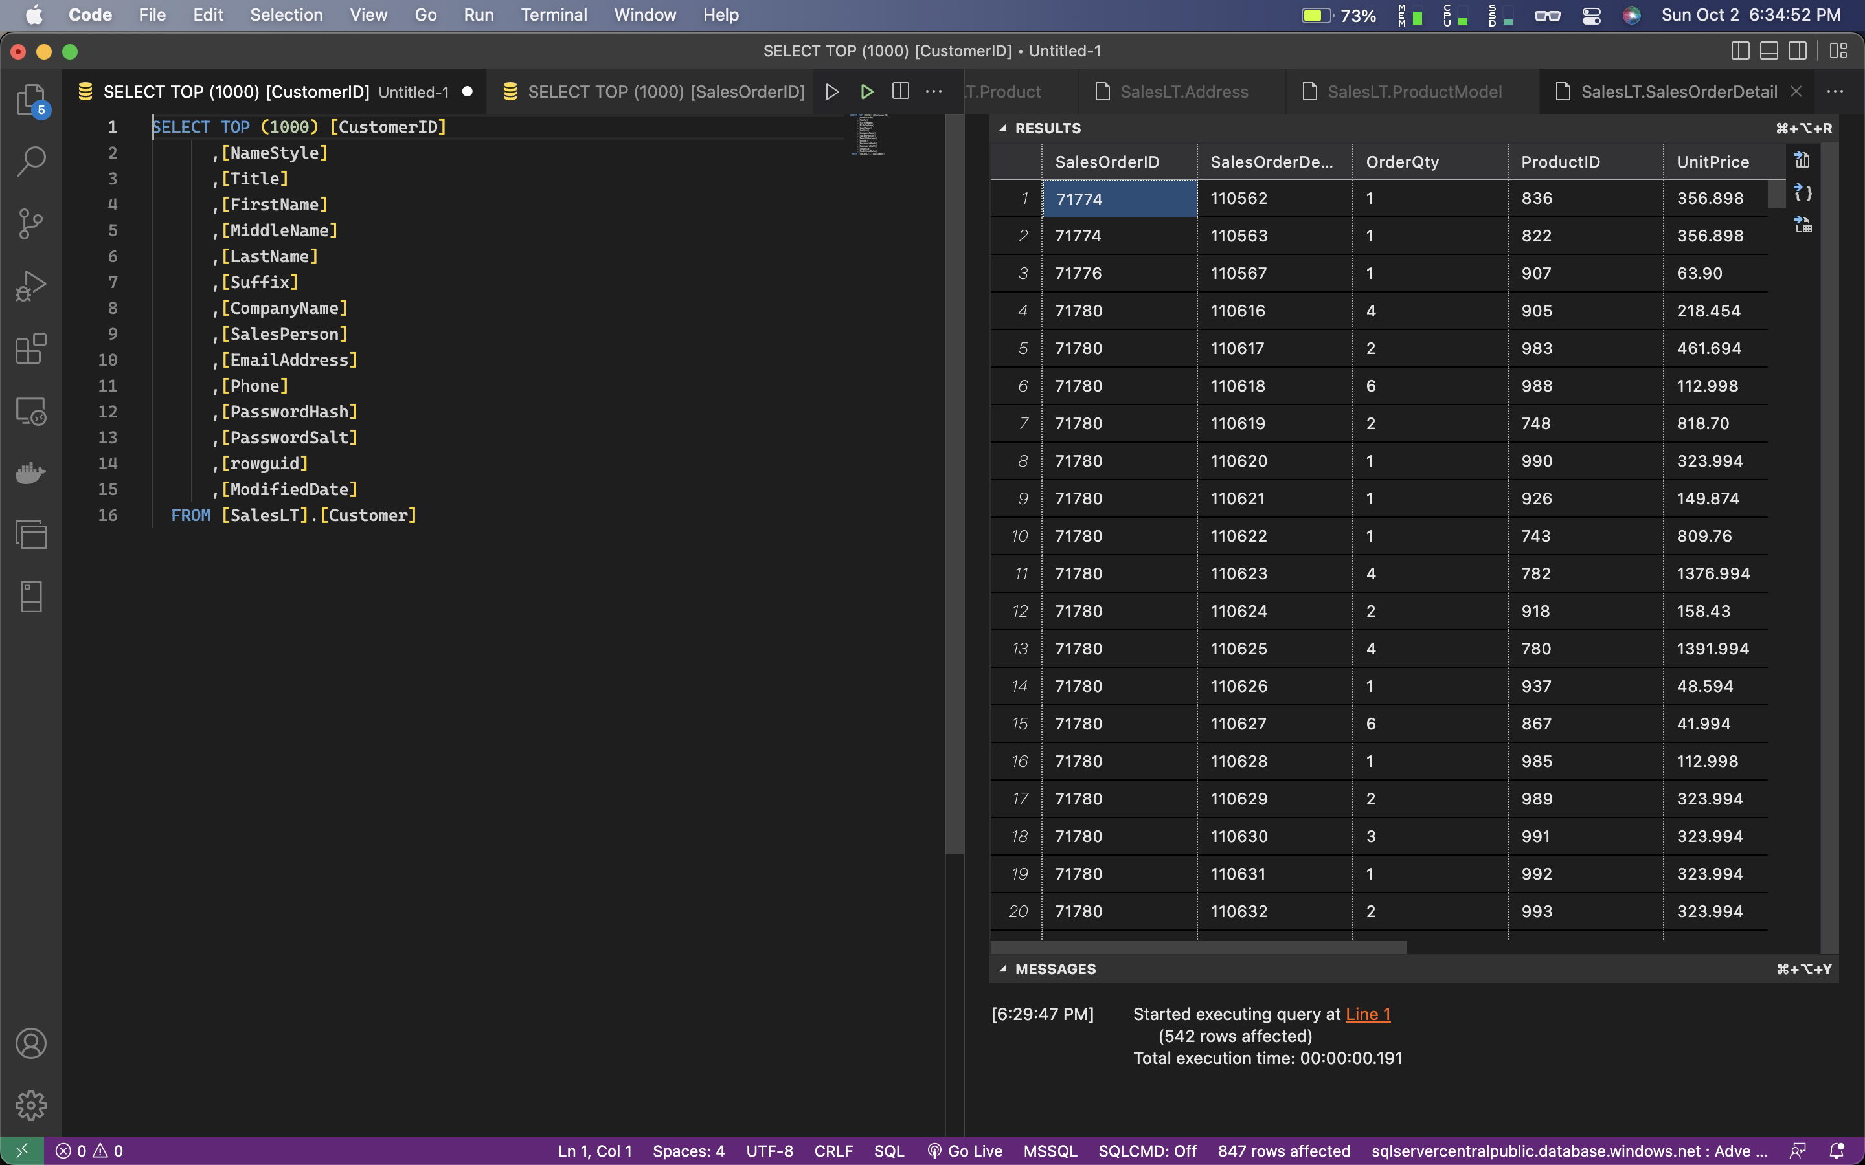

* + Product

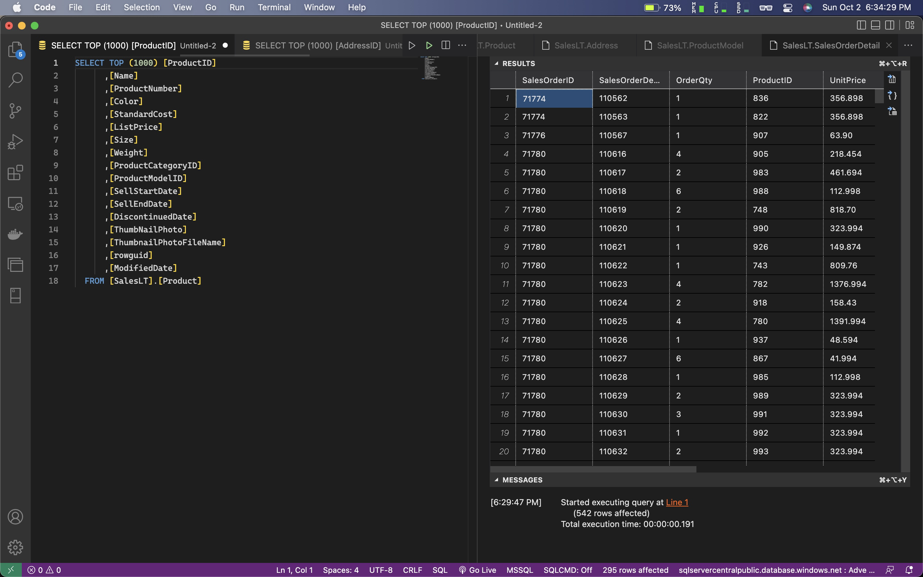

* + Address

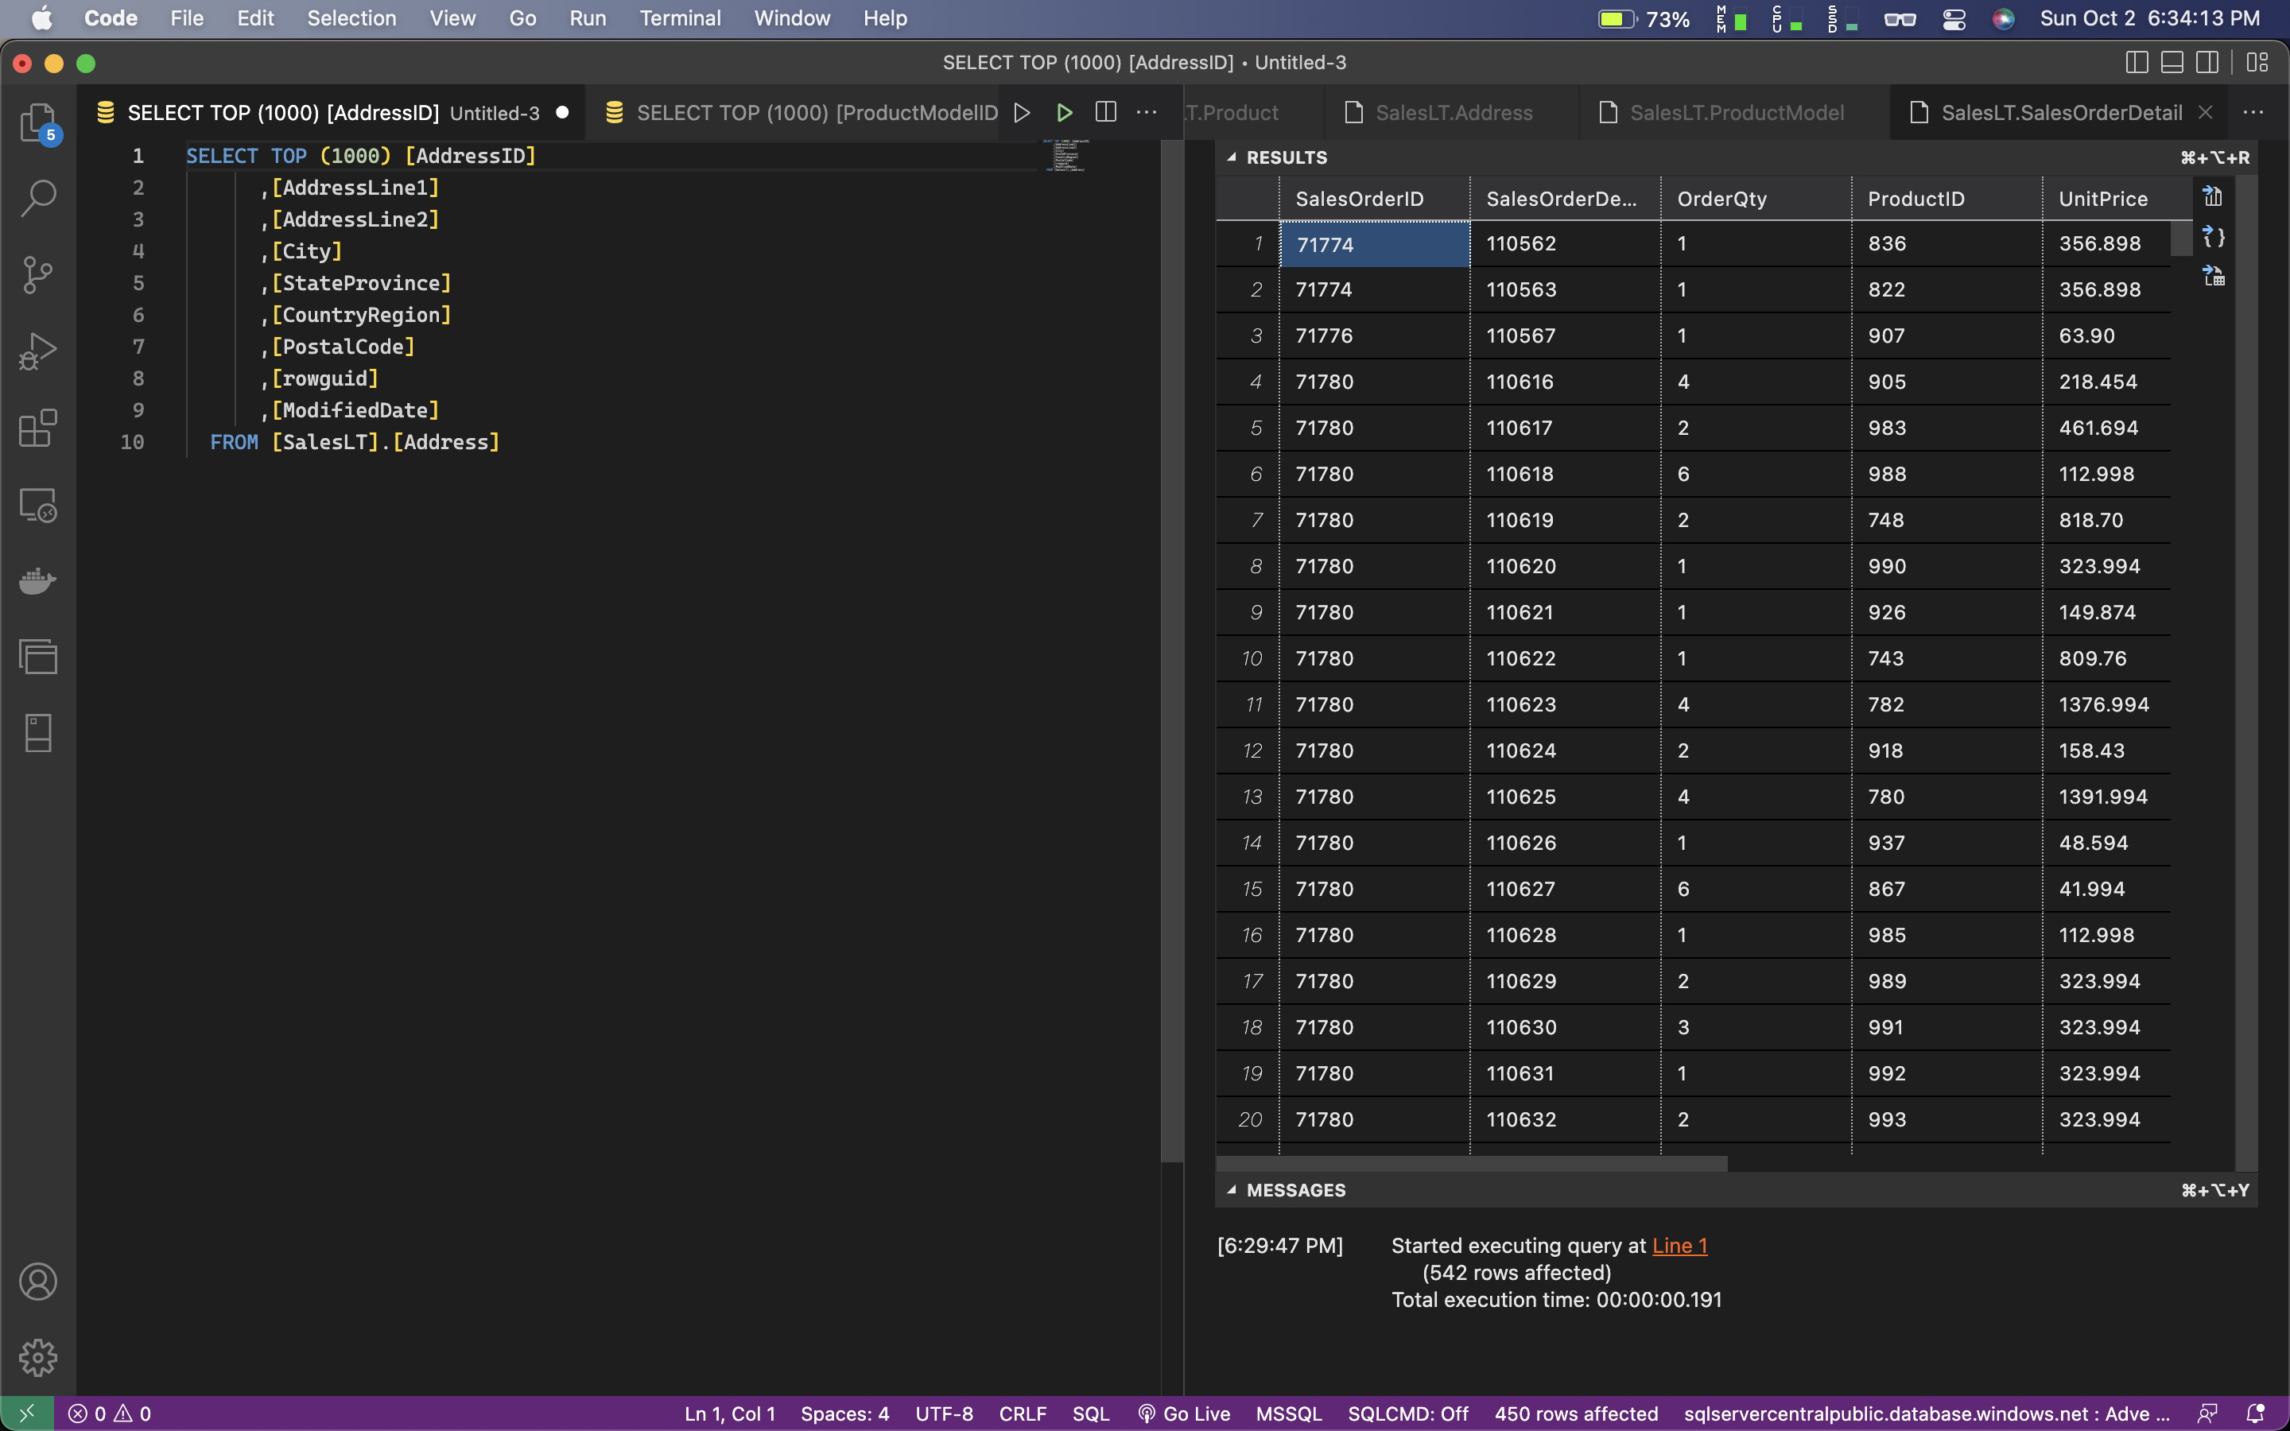

* + ProductModel

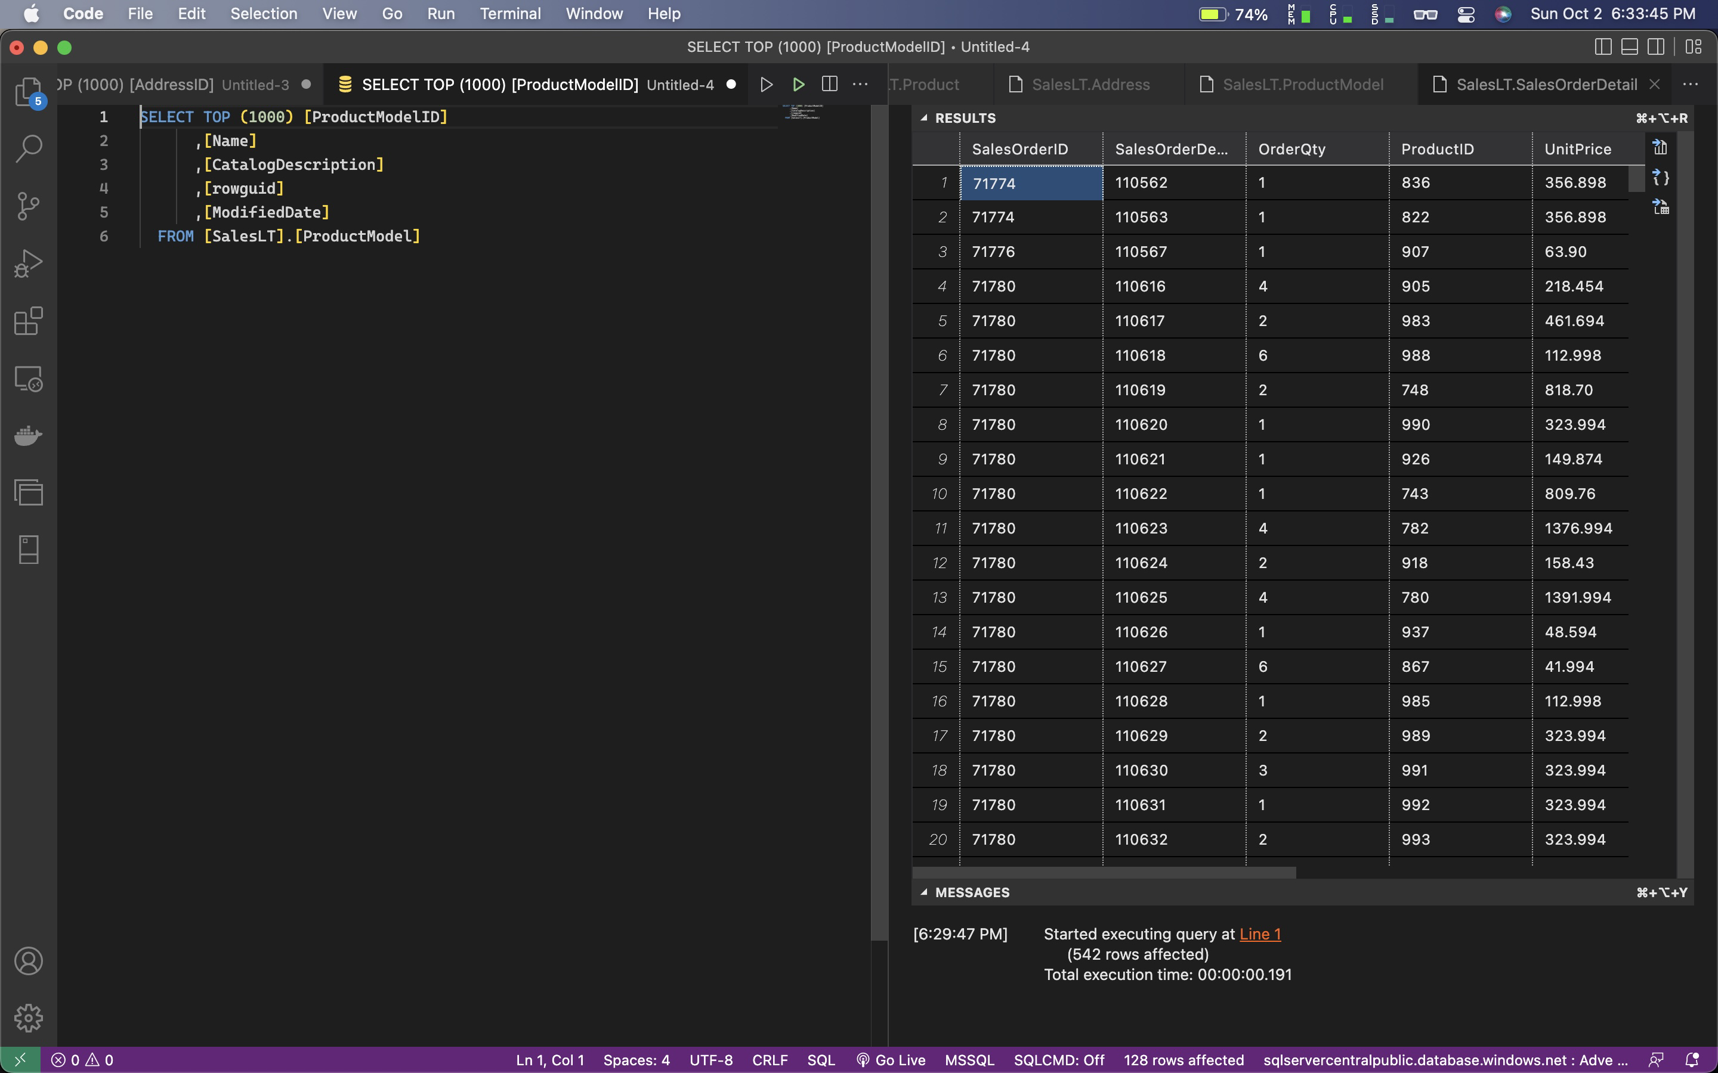

* + SalesOrder

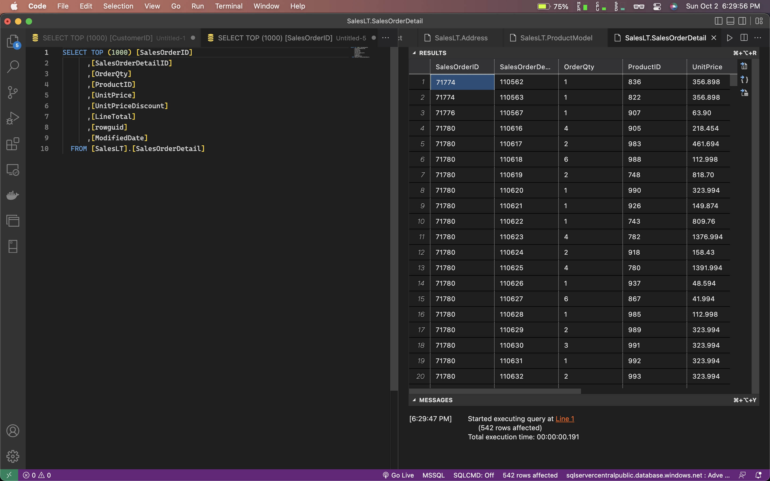

* Created Correct SQL statements to JOIN Data in more than one table  
  Show an example of joining two tables using COMPLETE SQL STATEMENTS with related data.

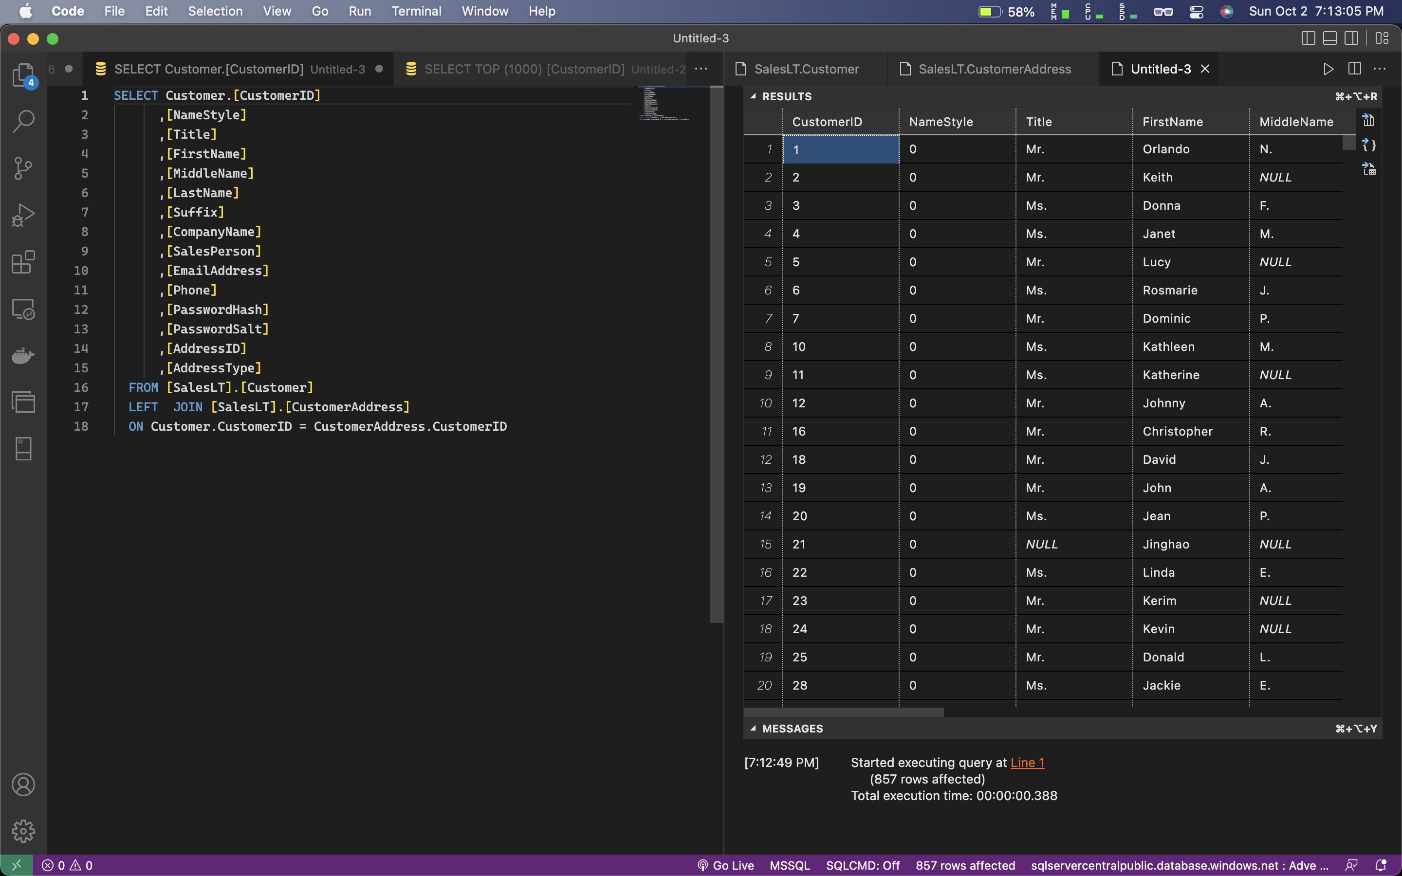

* Provides Screen Shots of all output results

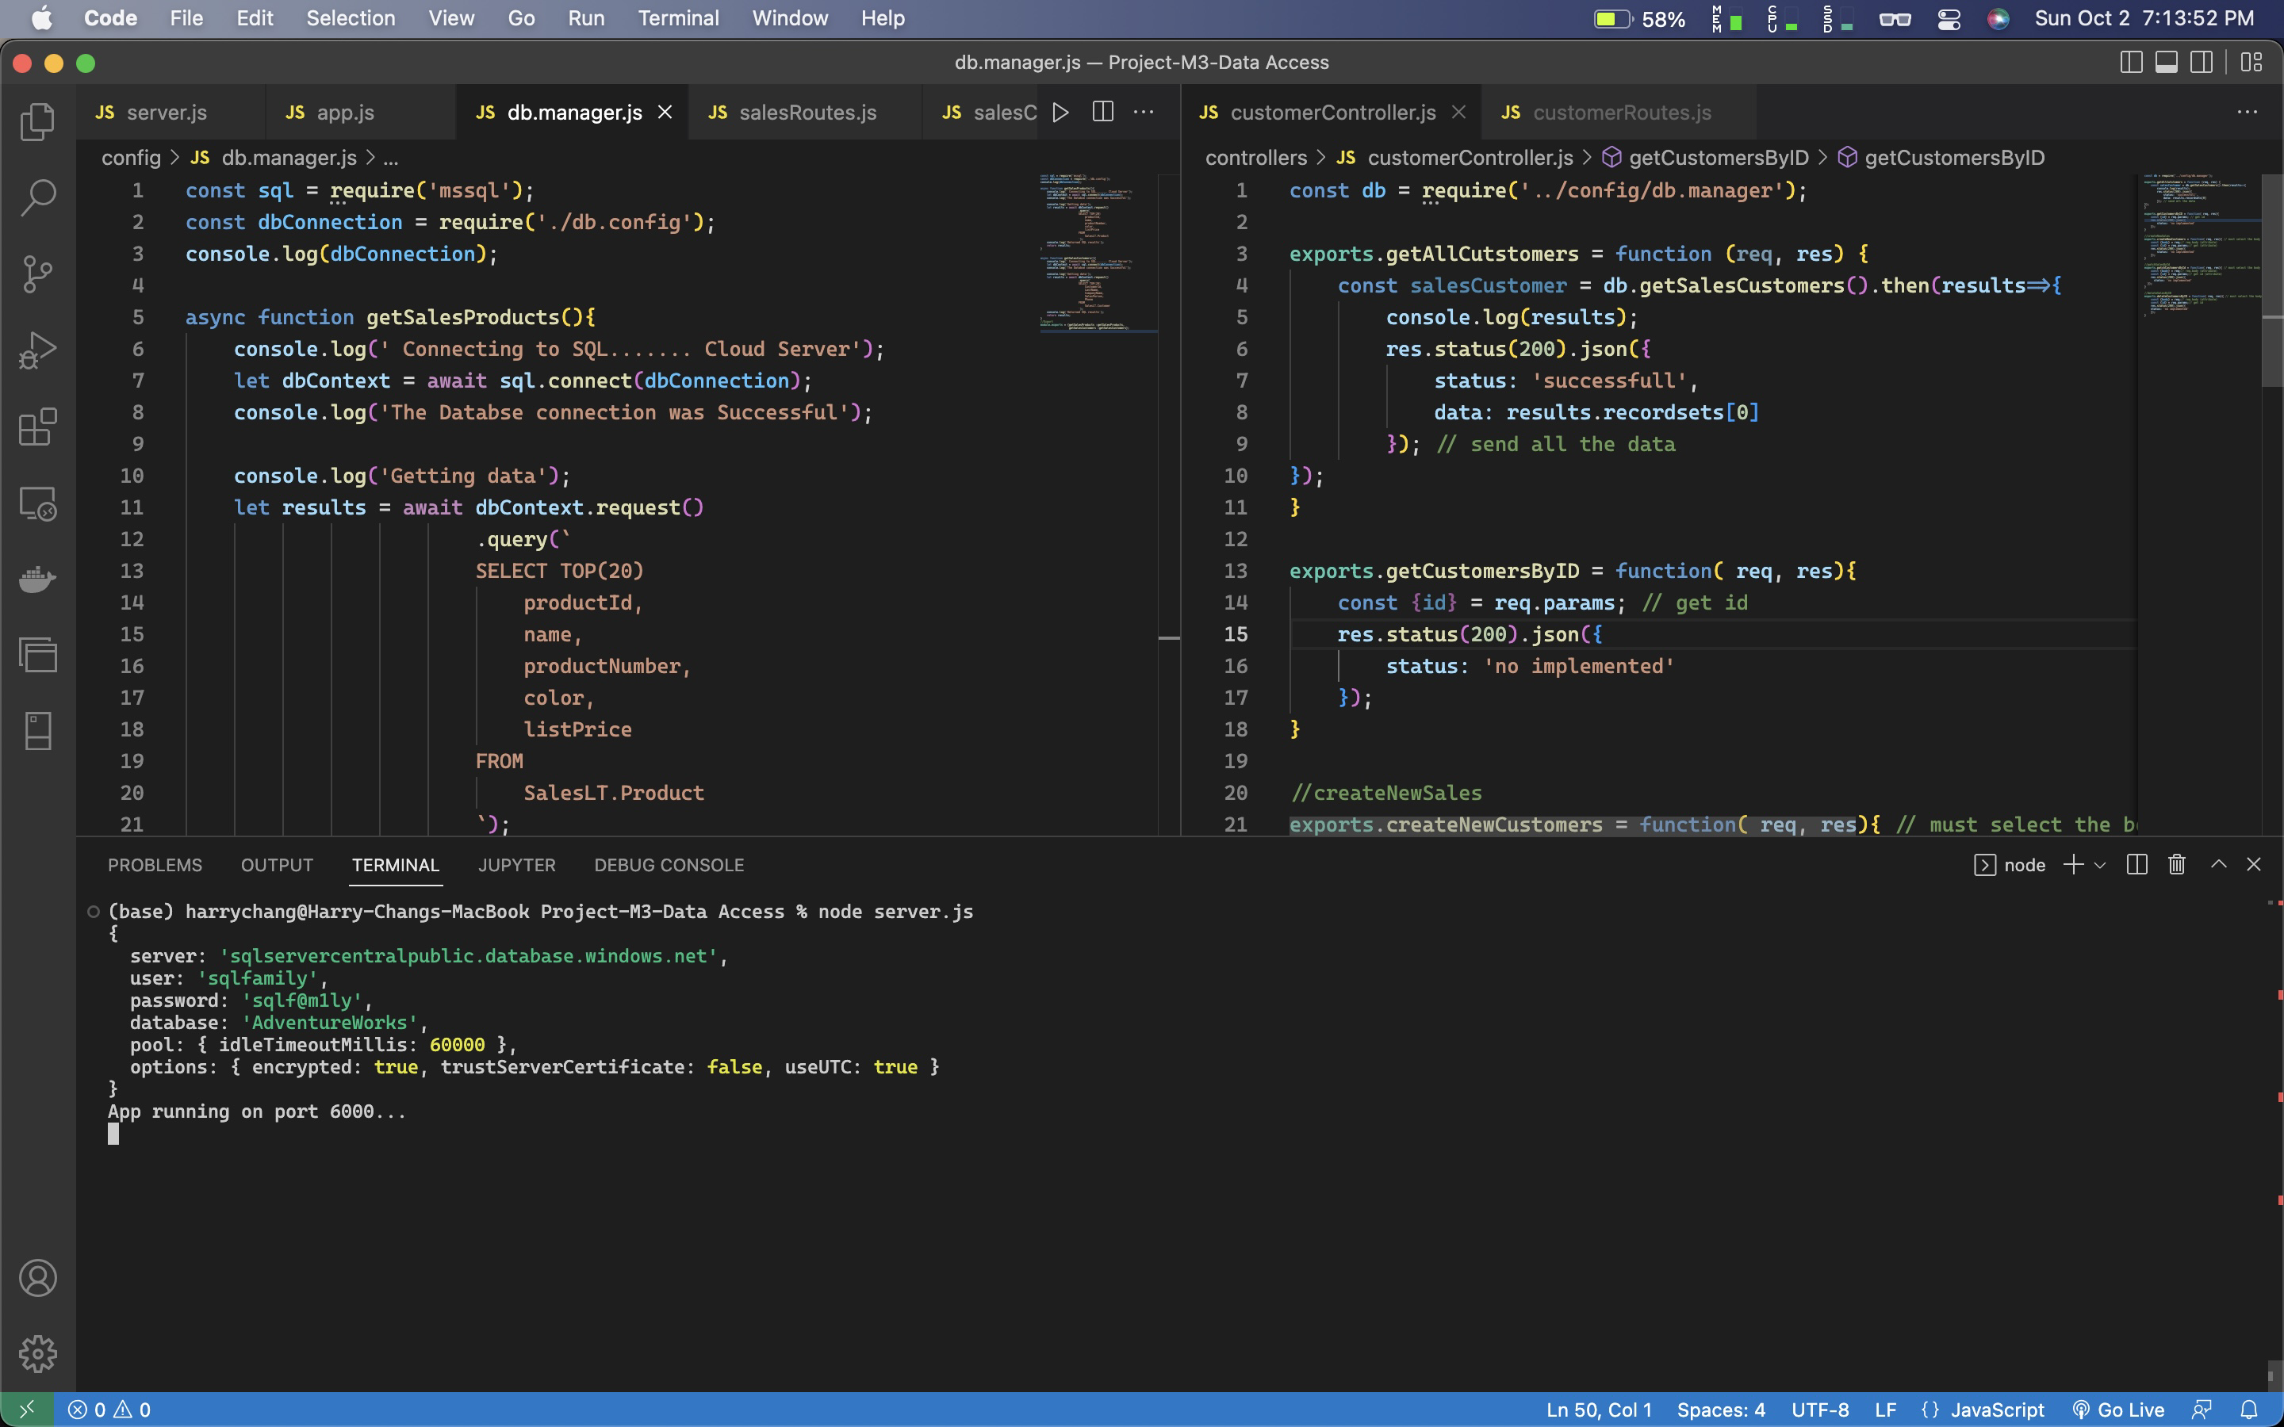

/api/v1/sales

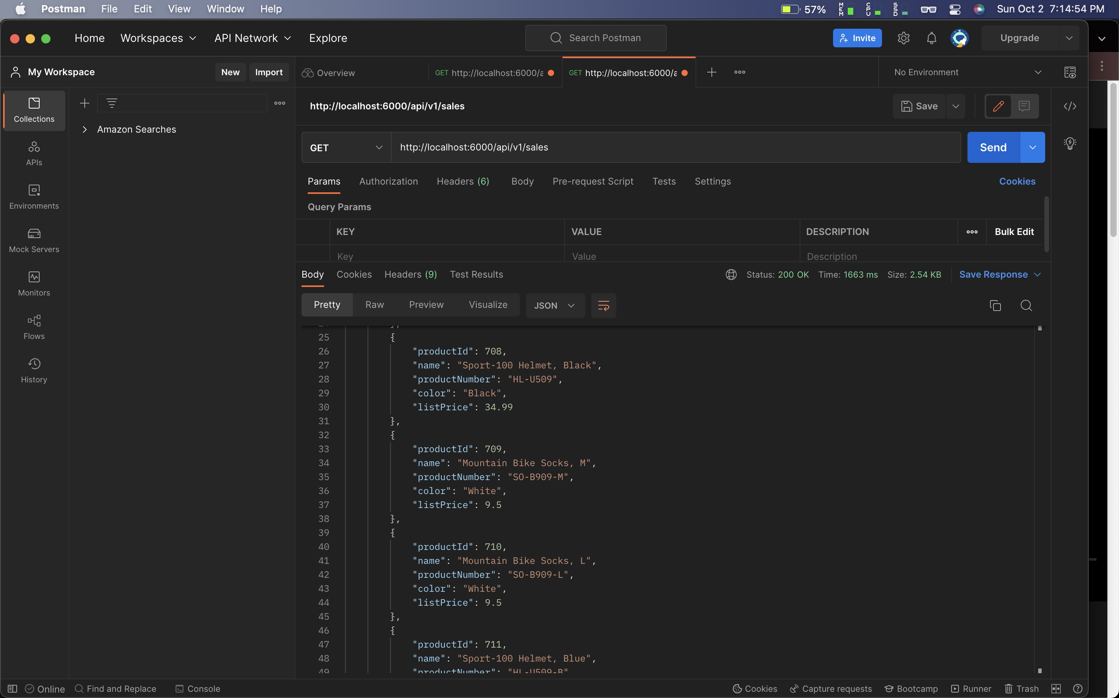

/api/v1/customers

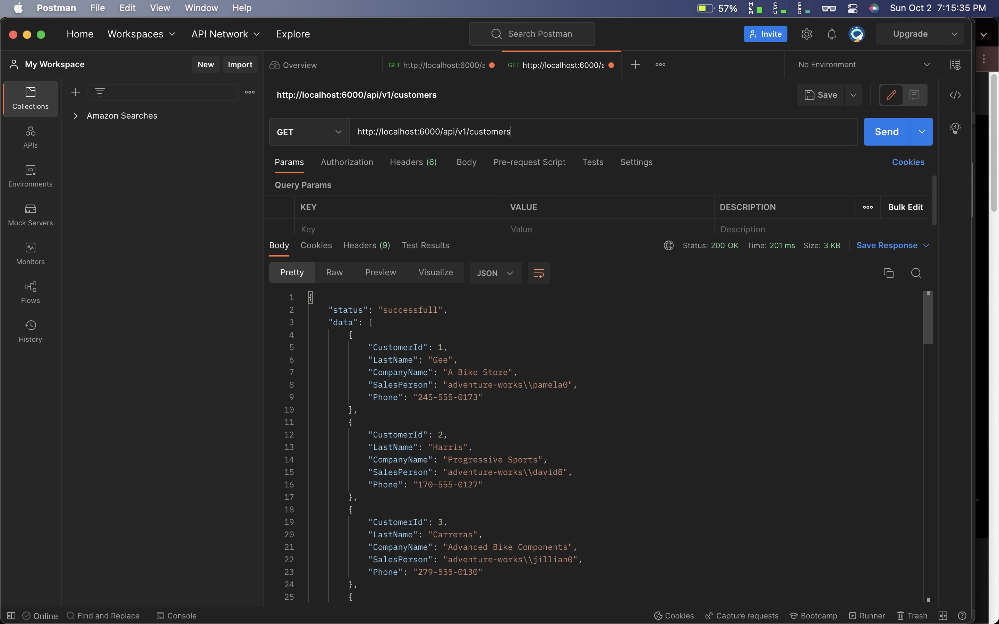

* Code:

app.js

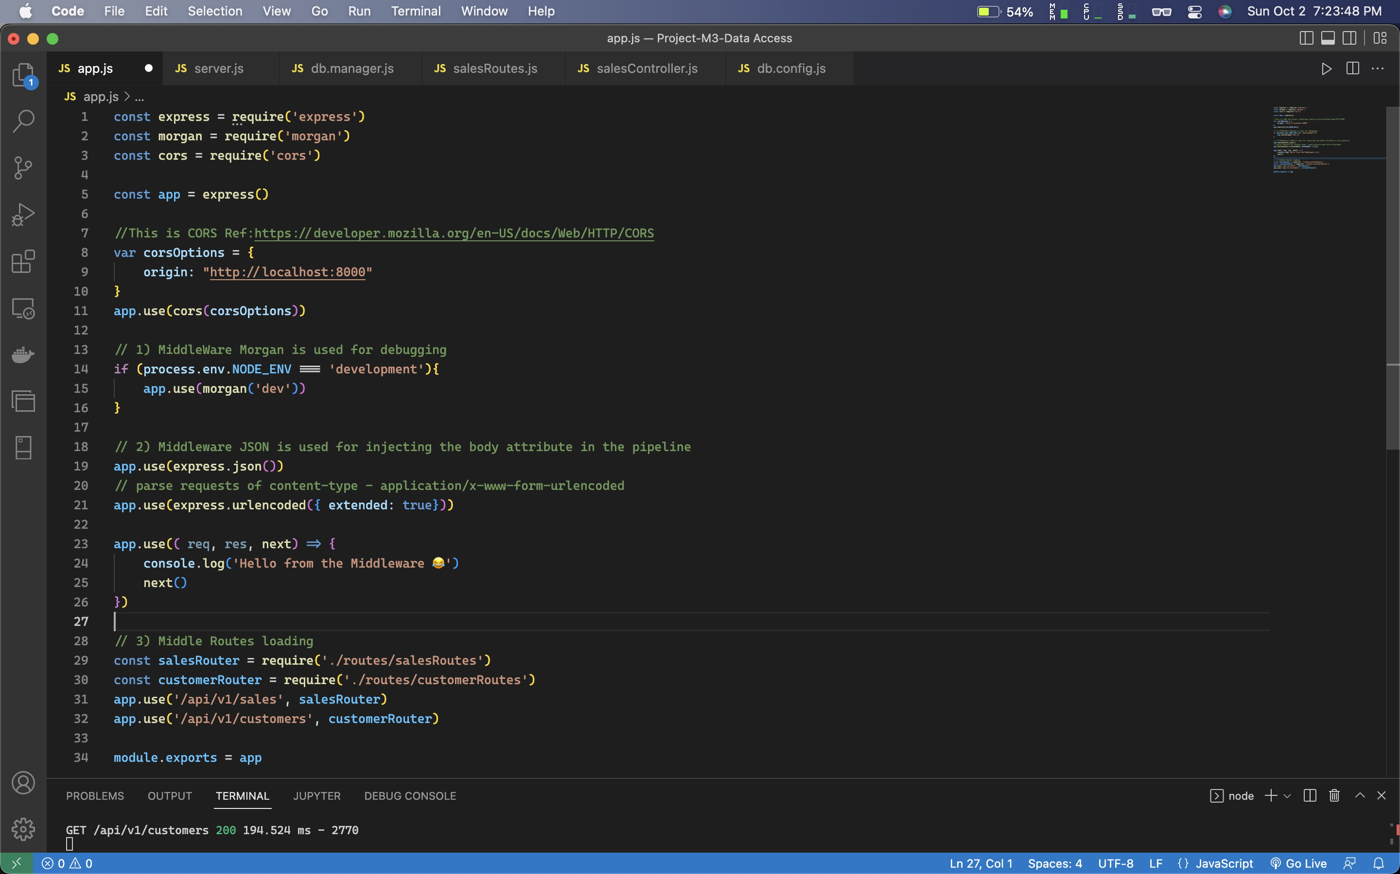

const express = require('express')

const morgan = require('morgan')

const cors = require('cors')

const app = express()

//This is CORS Ref:https://developer.mozilla.org/en-US/docs/Web/HTTP/CORS

var corsOptions = {

origin: "http://localhost:8000"

}

app.use(cors(corsOptions))

// 1) MiddleWare Morgan is used for debugging

if (process.env.NODE_ENV === 'development'){

app.use(morgan('dev'))

}

// 2) Middleware JSON is used for injecting the body attribute in the pipeline

app.use(express.json())

// parse requests of content-type - application/x-www-form-urlencoded

app.use(express.urlencoded({ extended: true}))

app.use(( req, res, next) => {

console.log('Hello from the Middleware 😂')

next()

})

// 3) Middle Routes loading

const salesRouter = require('./routes/salesRoutes')

const customerRouter = require('./routes/customerRoutes')

app.use('/api/v1/sales', salesRouter)

app.use('/api/v1/customers', customerRouter)

module.exports = app

server.js

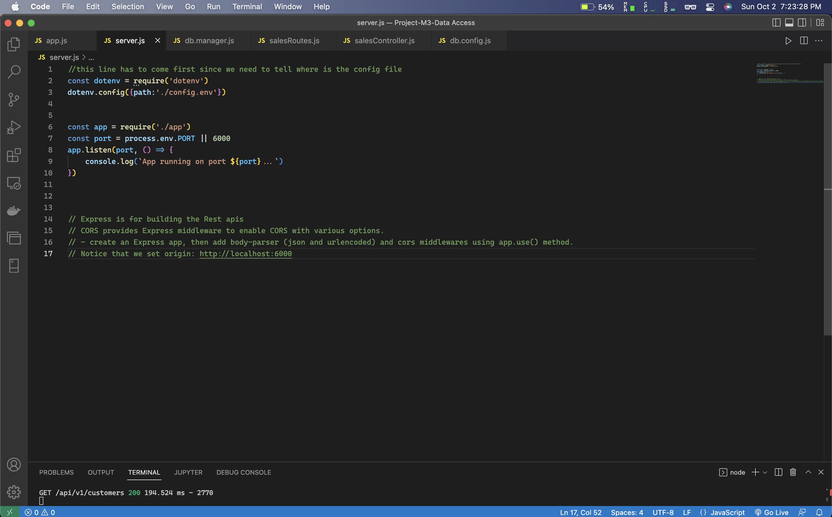

//this line has to come first since we need to tell where is the config file

const dotenv = require('dotenv')

dotenv.config({path:'./config.env'})

const app = require('./app')

const port = process.env.PORT || 6000

app.listen(port, () => {

console.log(`App running on port ${port}...`)

})

db.manager.js

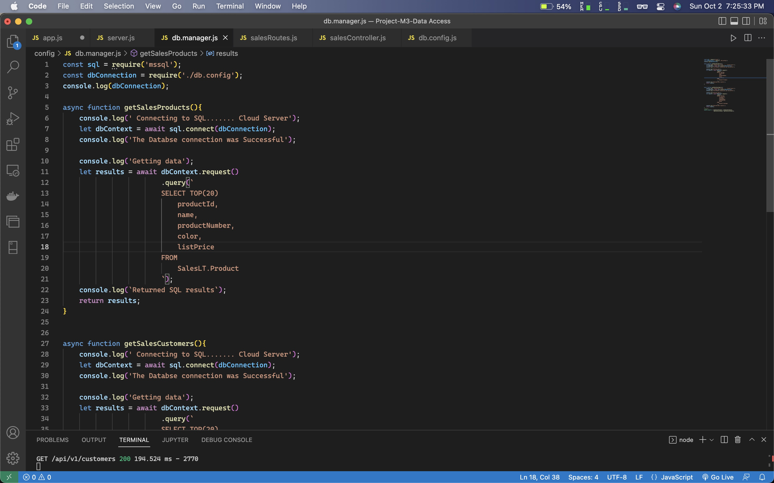

const sql = require('mssql');

const dbConnection = require('./db.config');

console.log(dbConnection);

async function getSalesProducts(){

console.log(' Connecting to SQL....... Cloud Server');

let dbContext = await sql.connect(dbConnection);

console.log('The Databse connection was Successful');

console.log('Getting data');

let results = await dbContext.request()

.query(`

SELECT TOP(20)

productId,

name,

productNumber,

color,

listPrice

FROM

SalesLT.Product

`);

console.log(`Returned SQL results`);

return results;

}

async function getSalesCustomers(){

console.log(' Connecting to SQL....... Cloud Server');

let dbContext = await sql.connect(dbConnection);

console.log('The Databse connection was Successful');

console.log('Getting data');

let results = await dbContext.request()

.query(`

SELECT TOP(20)

CustomerId,

LastName,

CompanyName,

SalesPerson,

Phone

FROM

SalesLT.Customer

`);

console.log(`Returned SQL results`);

return results;

}

//Export

module.exports = {getSalesProducts :getSalesProducts,

getSalesCustomers :getSalesCustomers};

salesRouters.js

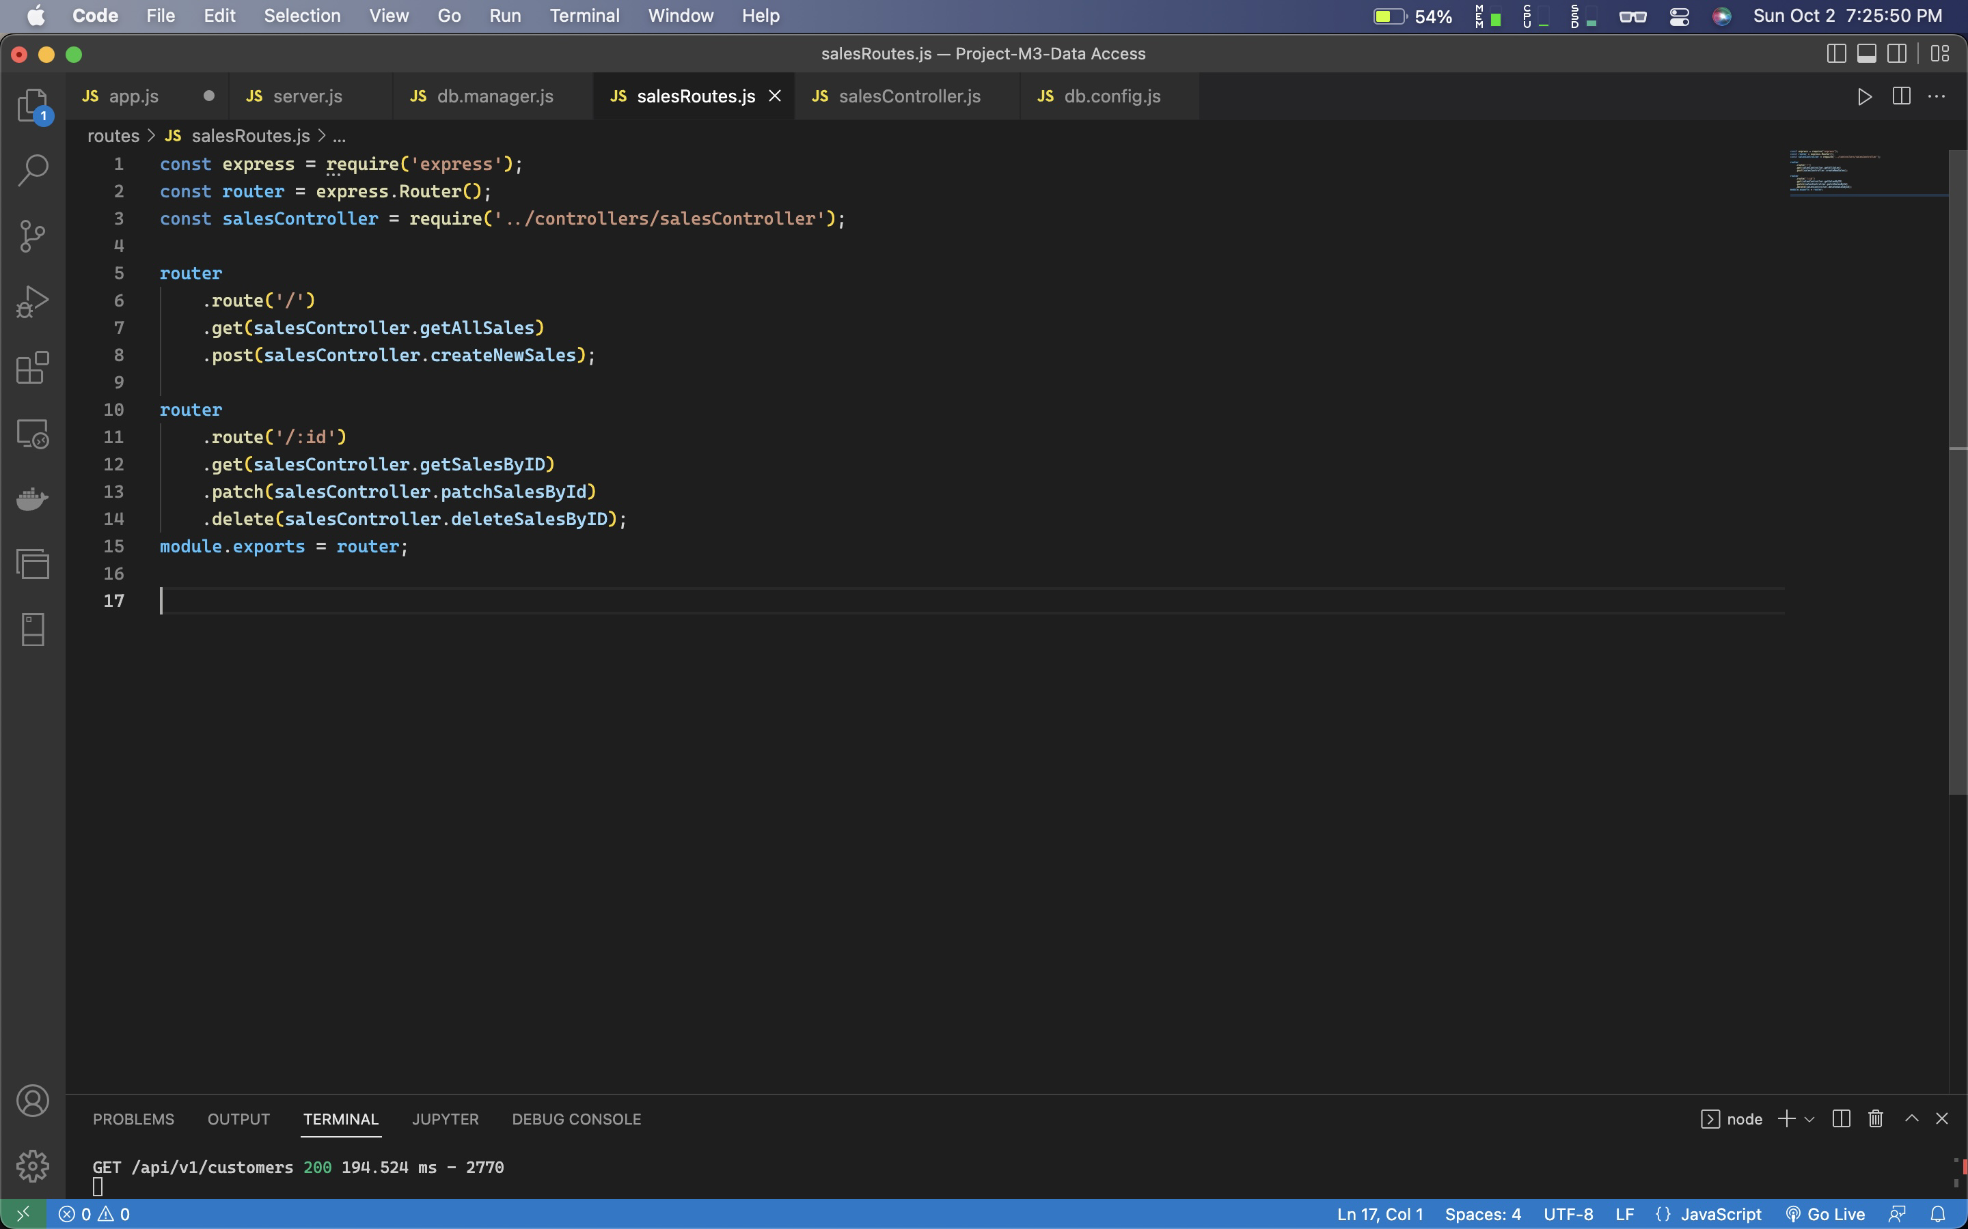

const express = require('express');

const router = express.Router();

const salesController = require('../controllers/salesController');

router

.route('/')

.get(salesController.getAllSales)

.post(salesController.createNewSales);

router

.route('/:id')

.get(salesController.getSalesByID)

.patch(salesController.patchSalesById)

.delete(salesController.deleteSalesByID);

module.exports = router;

salesController.js

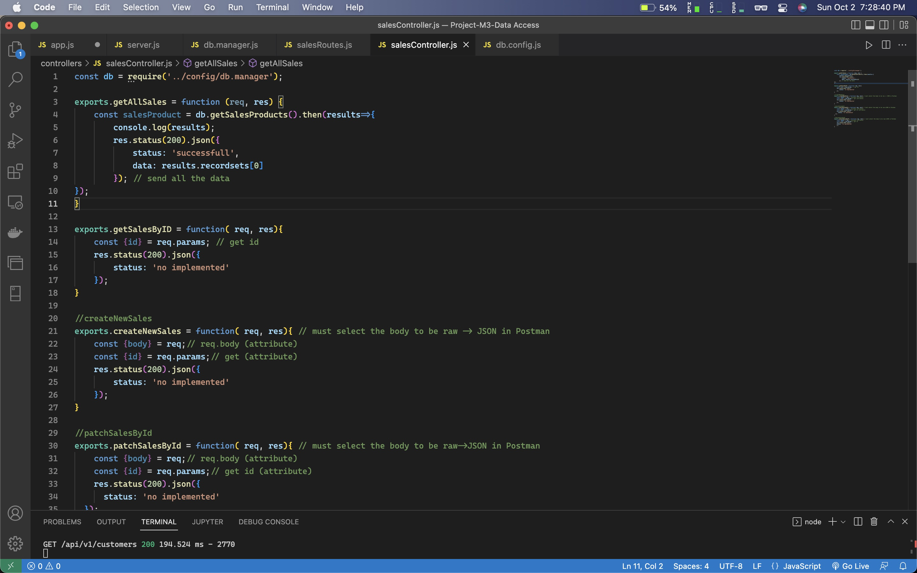

const db = require('../config/db.manager');

exports.getAllSales = function (req, res) {

const salesProduct = db.getSalesProducts().then(results=>{

console.log(results);

res.status(200).json({

status: 'successfull',

data: results.recordsets[0]

}); // send all the data

});

}

exports.getSalesByID = function( req, res){

const {id} = req.params; // get id

res.status(200).json({

status: 'no implemented'

});

}

//createNewSales

exports.createNewSales = function( req, res){ // must select the body to be raw -> JSON in Postman

const {body} = req;// req.body (attribute)

const {id} = req.params;// get (attribute)

res.status(200).json({

status: 'no implemented'

});

}

//patchSalesById

exports.patchSalesById = function( req, res){ // must select the body to be raw->JSON in Postman

const {body} = req;// req.body (attribute)

const {id} = req.params;// get id (attribute)

res.status(200).json({

status: 'no implemented'

});

}

//deleteSalesByID

exports.deleteSalesByID = function( req, res){ // must select the body to be raw->JSON in Postman

const {body} = req;// req.body (attribute)

const {id} = req.params;// get id

res.status(200).json({

status: 'no implemented'

});

}

db.config.js

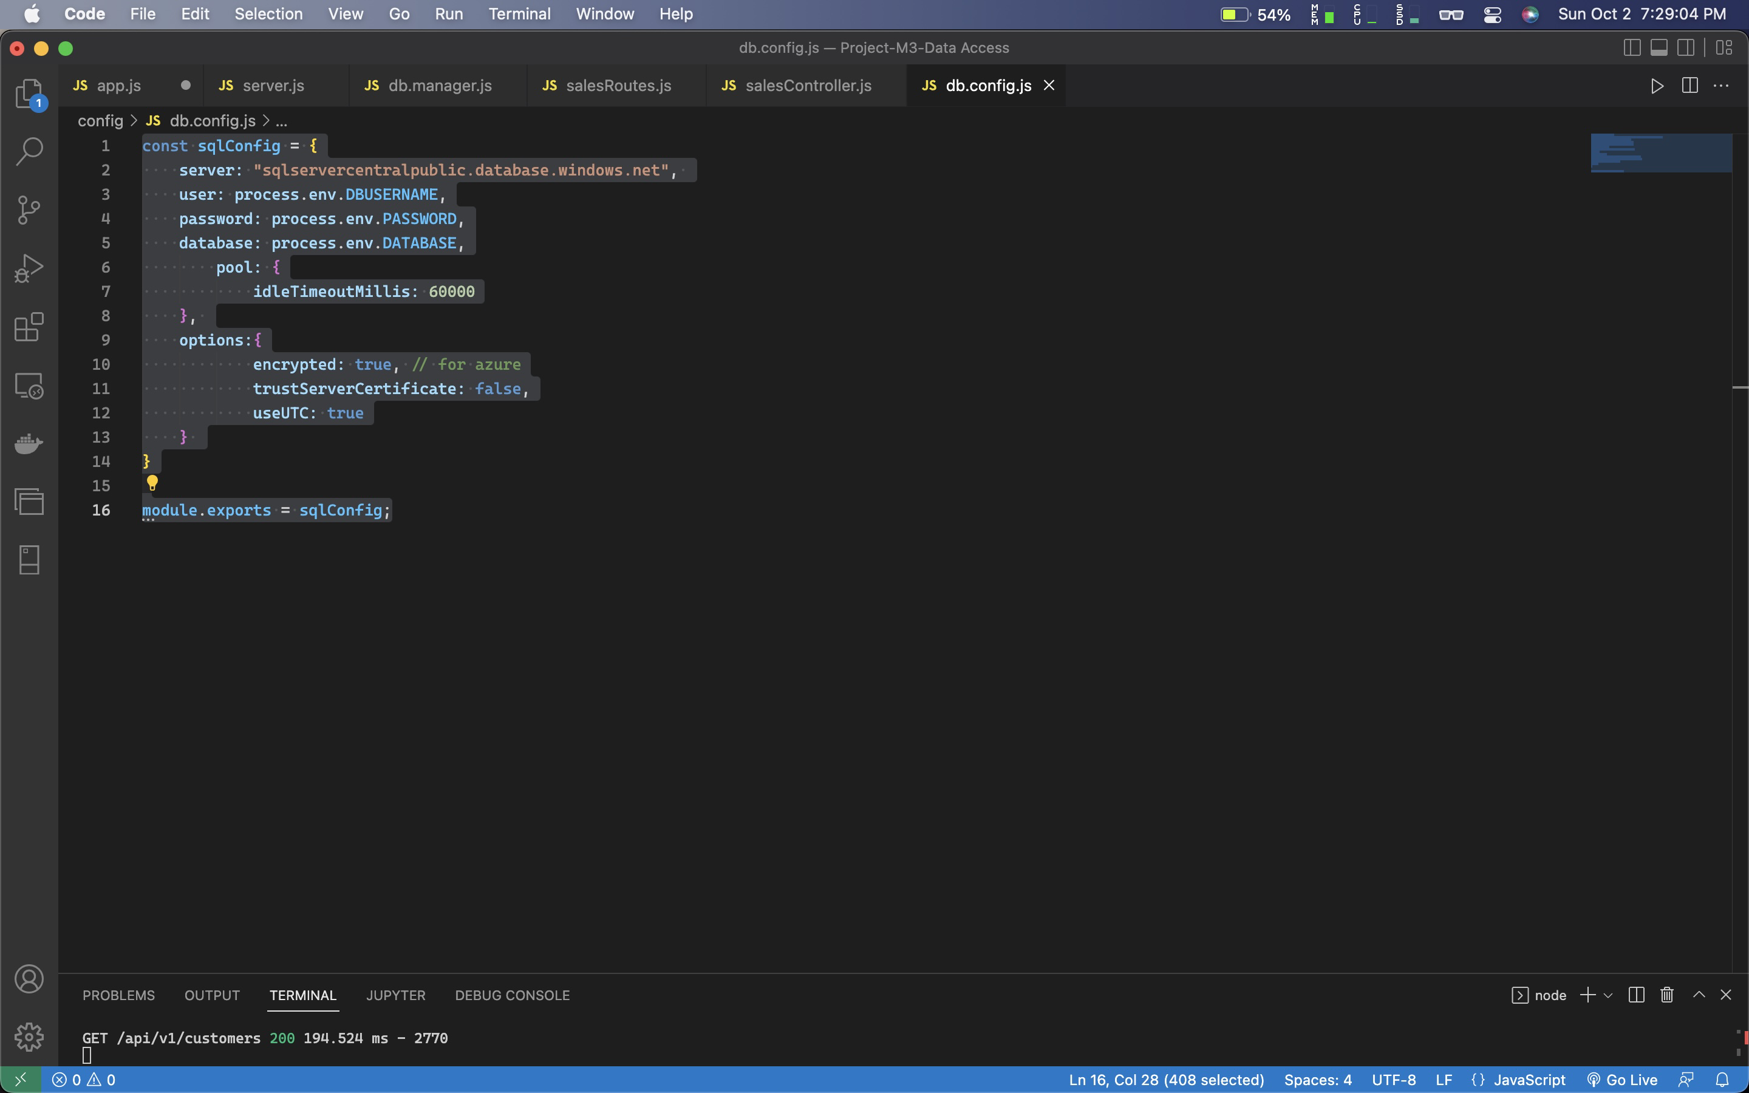

const sqlConfig = {

server: "sqlservercentralpublic.database.windows.net",

user: process.env.DBUSERNAME,

password: process.env.PASSWORD,

database: process.env.DATABASE,

pool: {

idleTimeoutMillis: 60000

},

options:{

encrypted: true, // for azure

trustServerCertificate: false,

useUTC: true

}

}

module.exports = sqlConfig;

customerController.js

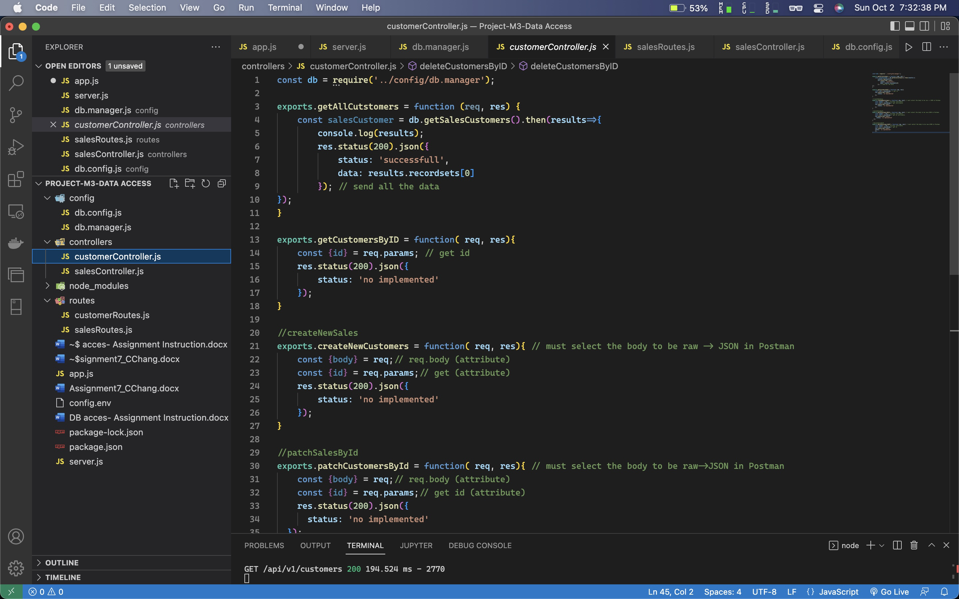

const db = require('../config/db.manager');

exports.getAllCutstomers = function (req, res) {

const salesCustomer = db.getSalesCustomers().then(results=>{

console.log(results);

res.status(200).json({

status: 'successfull',

data: results.recordsets[0]

}); // send all the data

});

}

exports.getCustomersByID = function( req, res){

const {id} = req.params; // get id

res.status(200).json({

status: 'no implemented'

});

}

//createNewSales

exports.createNewCustomers = function( req, res){ // must select the body to be raw -> JSON in Postman

const {body} = req;// req.body (attribute)

const {id} = req.params;// get (attribute)

res.status(200).json({

status: 'no implemented'

});

}

//patchSalesById

exports.patchCustomersById = function( req, res){ // must select the body to be raw->JSON in Postman

const {body} = req;// req.body (attribute)

const {id} = req.params;// get id (attribute)

res.status(200).json({

status: 'no implemented'

});

}

//deleteSalesByID

exports.deleteCustomersByID = function( req, res){ // must select the body to be raw->JSON in Postman

const {body} = req;// req.body (attribute)

const {id} = req.params;// get id

res.status(200).json({

status: 'no implemented'

});

}

customerRoutes.js

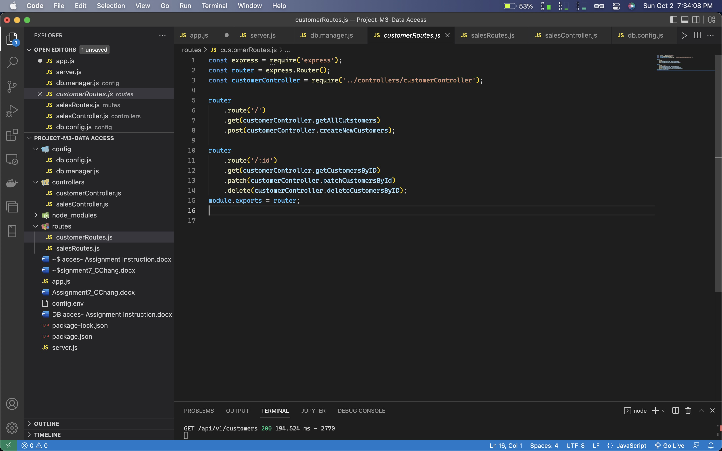

const express = require('express');

const router = express.Router();

const customerController = require('../controllers/customerController');

router

.route('/')

.get(customerController.getAllCutstomers)

.post(customerController.createNewCustomers);

router

.route('/:id')

.get(customerController.getCustomersByID)

.patch(customerController.patchCustomersById)

.delete(customerController.deleteCustomersByID);

module.exports = router;

config.env

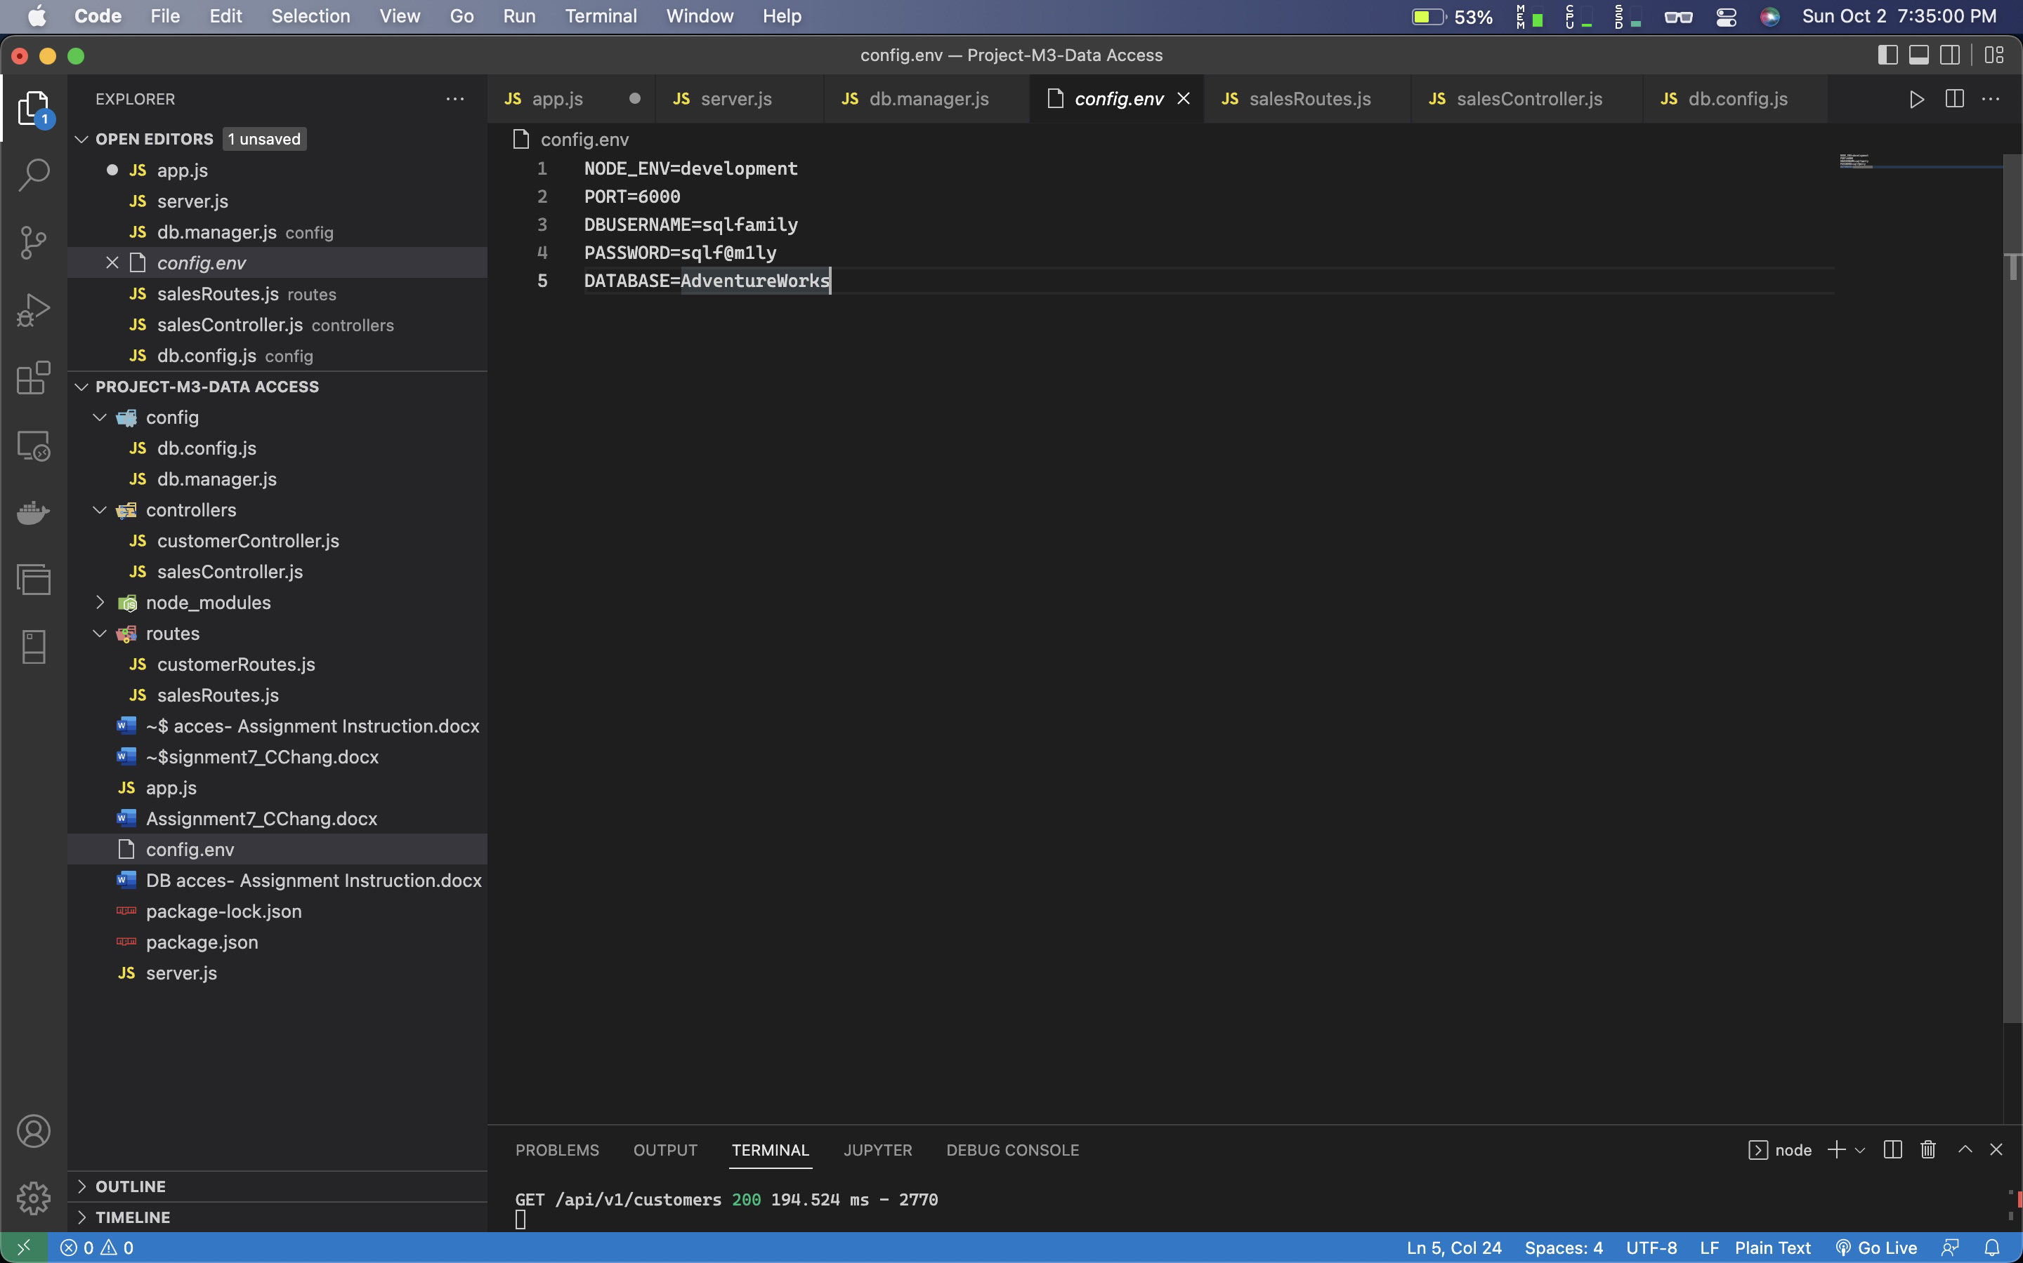

NODE_ENV=development

PORT=6000

DBUSERNAME=sqlfamily

PASSWORD=sqlf@m1ly

DATABASE=AdventureWorks